Assignment02
- On February 15, 2005, the Gallup Organization released the results of a Gallup UK poll regarding Internet usage in Great Britain. Each of 1,009 randomly selected UK adults was asked to respond to the following question:
How much time, if at all, do you personally spend using the Internet-more than an hour a day, up to one hour a day, a few times a week, a few times a month or less, or never?
The poll’s results were as follows: More than an hour a day (22%); Up to an hour a day (14%); A few times a week (15%); A few times a month or less (10%); Never (39%). Use these data to construct a bar chart and a pie chart.
Solution:

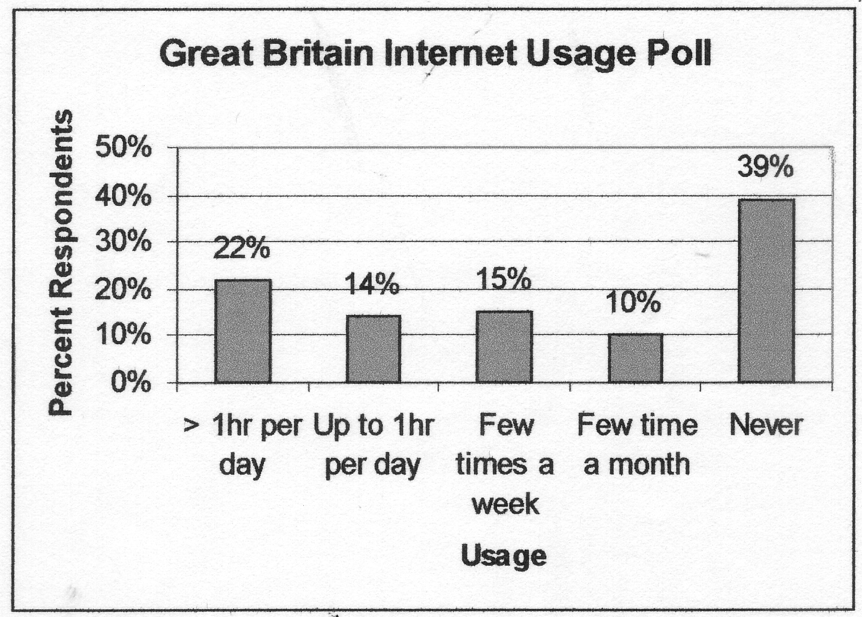
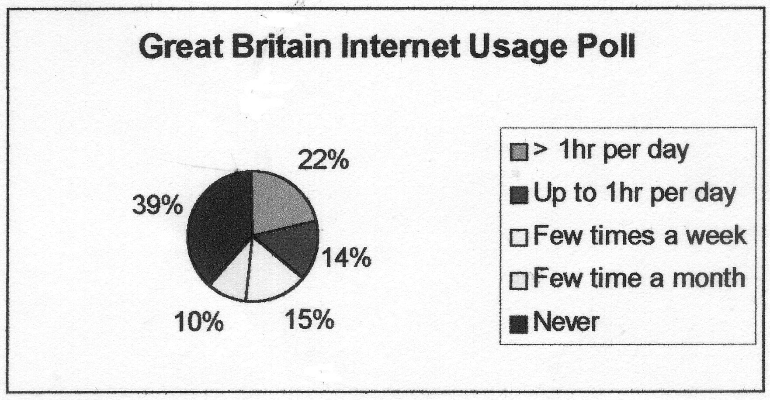

- Thirteen internists in the Midwest are randomly selected, and each internist is asked to report last year’s income. The incomes obtained (in thousands of dollars) are 152, 144, 162,154, 146, 241, 127, 141, 171, 177, 138, 132, 192, 188, 101 . Find :
  - The 90th percentile.
  - The median.
  - The first quartile.
  - The third quartile
  - The 10th percentile.
  - The interquartile range.
  - Develop a five-number summary and a box-and-whiskers display.
Solution:
a. 192 b. 152 c. 141 d. 171 e. 132 f. 30
g.
 | Income (1000's)
minimum | 127
maximum | 241
1st quartile | 141.00
median | 152.00
3rd quartile | 171.00

- According to the Morningstar.com website, the 2004 total return percentages for several popular funds were as follow:

Fund | 2004  Total Return%
Vanguard 500 Index | 10.7
Wasatch Core Growth | 21.7
Fidelity Stock Selector | 9.9
Fidelity Dividend Growth | 6.0
Janus Worldwide | 5.2

Suppose that an investor had $100,000 invested in the Vanguard 500 Index fund, $500,000 invested in the Wasatch Core Growth fund, $500,000 invested in the Fidelity Stock Selector fund, $200,000 invested in the Fidelity Dividend Growth fund, and $50,000 invested in the Janus Worldwide fund.
a. Compute a weighted mean that measures the 2004 average total return for the investor’s portfolio.
- Compare your weighted mean with the unweighted mean of the five total return percentages. Explain why they differ.
Solution:
a. 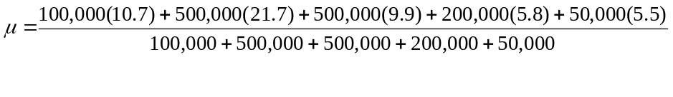 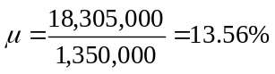
- unweighted mean = 10.72%

